
ClassifyIt 7.0
User Manual
ClassifyIt, an Add-In for Outlook, Word, Excel, PowerPoint

support@ugarbe.de
2026
Table of Contents
Article I. Introduction 5
Section 1.01 Why use ClassifyIt 5
Section 1.02 ClassifyIt Key Capabilities 6
Section 1.03 What is a Classification Marking 7
(a) Visual and Technical Classification Marking 8
(b) Translated Classification Markings 8
Section 1.04 How ClassifyIt integrates in Office Applications 9
Article II. ClassifyIt Functions 10
Section 2.01 ClassifyIt Menu 10
(a) Assign Metadata 11
Section 2.02 Release Form 12
Section 2.03 CryptIt – Word, PowerPoint, Excel 13
(a) Export PDF 13
(b) Export TDF 14
(c) Import TDF 14
(d) Certificate Management 15
Section 2.04 CryptIt – Outlook 17
(a) Encryption 17
(b) Save a Public Key 20
(a) Attach my Public Key 20
Article III. Public-Private Key Concept - how to use certificates 21
Article IV. PDF Export 22
Article V. Word Paragraph Marking 23
Article VI. Outlook Behaviour 26
Section 6.01 Email Without a Classification 26
Section 6.02 Quick Select in Outlook 26
Section 6.03 Email With Unapproved Attachment Type 27
Section 6.04 Reply or Forward with Lower Classification 27
Annex A – Certificate Exchange Walkthrough 28
Step 1 – Alice Generates Her Certificate 28
Step 2 – Alice Sends Her Public Key to Bob 28
Step 3 – Bob Imports Alice's Public Key 28
Step 4 – Bob Generates His Certificate and Sends It to Alice 29
Step 5 – Alice Encrypts for Bob Using Certificate Encryption 29
Step 6 – Bob Decrypts Alice's Message 29

Introduction

Why use ClassifyIt
ClassifyIt is an information security support tool that enables users to apply policy-compliant classification markings to emails and documents, add data loss prevention information, and encrypt documents when distributing them over unprotected networks such as the Internet. ClassifyIt is designed to be powerful in its core functions and easy and intuitive for users and administrators.
Information security starts when writing or updating documents. Mark the document with a visible classification marking, such as SECRET, to ensure that you and others understand the sensitivity of the information within the document. ClassifyIt enforces classification marking and helps users select the correct marking.
Adding such a classification marking manually is possible without a tool, so the obvious and legitimate question is why use ClassifyIt? The answer depends on the kind of business and the size of your organisation. Very small companies might not require such a tool, although marking personal data might be a legal requirement (for example under GDPR) and a tool can help mark such data properly. Competitive, innovative and growing companies own and manage information that makes them unique, and this critical information must not become public or available to their competitors. ClassifyIt helps enforce a visual, human-readable marking as shown above, and adds a technical marking that supports DLP technologies.
The ISO 27001 standard requires the implementation of information classification. ClassifyIt is a highly flexible tool for supporting this requirement. Alongside the tool that enforces classification markings, policies and handling procedures are necessary to provide a common ruleset for your users.

ClassifyIt Key Capabilities
ClassifyIt is a Plug-In for Microsoft Outlook, Word, PowerPoint and Excel applications, of the Microsoft Office Suite (2010 and higher).
ClassifyIt supports Data Loss Prevention (DLP) by enforcing or supporting the insertion of security classification markings. DLP is supported by readable security markings and non-readable information to emails (X-Header) and documents (properties). Both can support network security DLP measures through mailguards, web firewalls or other proxy mechanisms.
ClassifyIt supports the enforcement of classification markings on emails, Word documents, PowerPoint presentations and Excel spreadsheets. The markings are configured to comply with the company's or organisation's security policy and can be made interoperable with other companies' markings.
ClassifyIt supports classification consistency so that an email cannot have a lower classification than its attachments.
ClassifyIt supports the selection of release markings to ensure compliance with company and organisation security policies. Release markings can support internal and external authorisation to share sensitive data.
ClassifyIt supports adding metadata to documents to improve search engine results. Document availability is improved by this feature.
ClassifyIt supports exporting Office documents to PDF documents while preserving readable and machine-readable classification marking information.
ClassifyIt supports classification as a service through central web control of configuration parameters.
ClassifyIt supports the encryption of documents and email attachments through verifiable and secure Trusted Data Format containers. Local support is currently in place for built-in protection (everyone with ClassifyIt can decrypt), PIN protection and certificate-based encryption.

What is a Classification Marking
A classification marking is a textual label that defines, at a high level, the sensitivity of a document and how that document may be shared internally or externally to your organisation. In the context of ClassifyIt, the sensitivity is called the classification and the sharing statement is called the release.
Below is an example of a Classification Marking, where the classification is SECRET, and the release is MANAGEMENT and FINANCE. The classification marking is the label showing the classification and release, in this case:
Classification: SECRET
REL TO: MANAGEMENT\\FINANCE
The label for such a classification marking must conform to your organisation's information management policy, which sets the classifications and their meaning, as well as whether your organisation requires release markings. The classification mainly represents the value of the information within a document, and the release (if used) indicates approval to further distribute the document.
A classification marking contains a classification and, optionally, a release marking. Your security administration or information management team defines those markings. For classifications there are normally between three and five categories, similar to those shown in the diagram above: OPEN, RESTRICTED or SECRET.
OPEN would apply to information that can be shared with everyone, where publishing such information on the internet would not reveal internal secrets of your organisation.
RESTRICTED would apply to information that has an official context within your own organisation or with external cooperation partners. This category could apply to information that would give competitors a certain but limited advantage if they became aware of it. Such information therefore needs to be protected with some care. Examples might include internal processes, certain price information or high-level technical information.
SECRET would apply to sensitive information that is very important to your organisation and must be handled with the highest care. This category could apply to information that would give competitors an advantage if they became aware of it. Such information therefore needs to be protected with the highest care. An example might be detailed technical information.

Visual and Technical Classification Marking
ClassifyIt is a Data Loss Prevention (DLP) tool that adds and enforces visual classification markings shown as text within the document. ClassifyIt also adds technical classification markings stored in document properties. ClassifyIt ensures that the visual and technical markings have the same value. Technical markings can be used by software to identify the document classification and enforce whether the document can be provided to a recipient. Those technical markings are stored as key-value pairs, either as a custom property for documents or an x-header in an email. The default key is named: iCLASS, and the value assigned follows the syntax and semantic of the iCLASS standard.
The section above showed a SECRET classification marking with a release. The technical marking is represented in a JSON notation and the iCLASS standard looks like:
iCLASS = {"org": "UGARBE", "class": "S", "rel": ["MAN", "FIN"]}
The values for "class" and "rel" are configurable by the administrator and must match entries in the classification schema. In this notation S represents SECRET, MAN represents MANAGEMENT, and FIN represents FINANCE. "org" is a short code identifying the originating organisation, also configured by the administrator. In real configurations "org" and "rel" could be country codes or organisational codes, like EU or UN or NATO.

Translated Classification Markings
For the visual classification marking, ClassifyIt allows the marking to be represented with a translation. This translation can be an additional visual line that standardises the classification marking. Such standardisation can be useful in international cooperation where the normal classification markings are not the same.
For more information, consult the case study on “International Classification – iCLASS”, available at https://classifyit.eu/case-study/iclass

This document also uses the feature of a translated classification marking, following the notation of the Global Standardised Classification Label (GSCL).
TLP:WHITE
iCLASS//Unclassified//

How ClassifyIt integrates in Office Applications
ClassifyIt integrates with Microsoft Outlook, Word, PowerPoint and Excel. If further applications are required, please contact the administrator, who can request this via support@ugarbe.de.
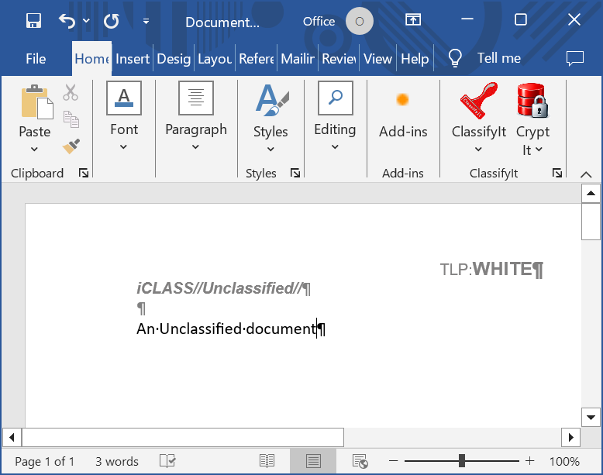
In all applications the ClassifyIt Menu is available. It comes with the ClassifyIt button to apply classifications to emails or documents, and the CryptIt button to encrypt, import and export documents and to support basic certificate operations.
Depending on the application, different functions are available under those main buttons. Both are split buttons, so there is a main function when pressing the top of the button and a menu when pressing the bottom of the button.
In Outlook the CryptIt component is slightly different because the main function of the button is to encrypt email attachments. In the other applications, CryptIt is mainly used to export the document to a secure and encrypted file type.

ClassifyIt Functions

ClassifyIt Menu
The ClassifyIt menu is available in all of the following applications: Outlook, Word, Excel and PowerPoint. In Outlook, it is visible when opening an email.
The ClassifyIt menu is a split button providing two functions. One is on the upper half and one is on the lower half of the button.
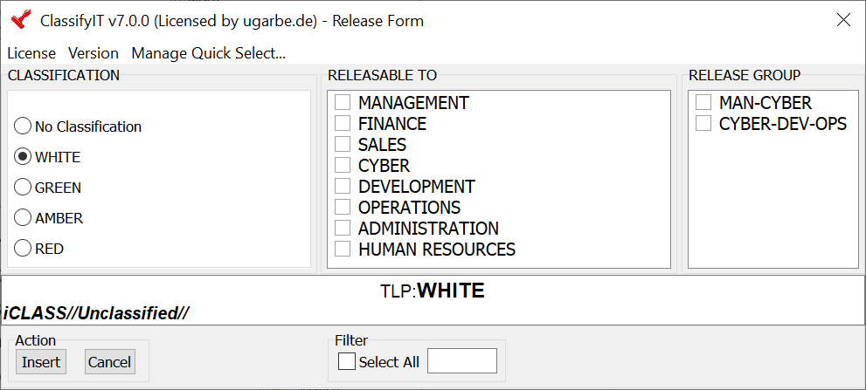
The upper half of the split button opens the full ClassifyIt menu, the Release Form. In this menu, the full variety of classifications and release markings can be selected. It provides a preview of the selected classification marking and supports filtering and selection of release markings (see Section 2.02). Insert applies the selected classification to the document; Cancel discards the selection.
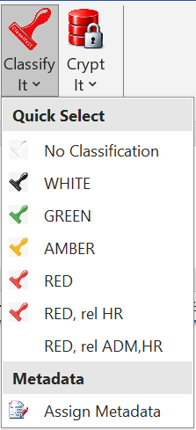
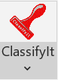
The lower half of the split button opens the integrated Quick Select menu. This menu provides a list of classification markings that are often used within the organisation. The number of entries is limited to 10 and is configurable (see Manage Quick Select below). If more entries are required, contact support@ugarbe.de. The Quick Select menu shows a display name for a particular classification marking and can include a classification and release marking. In essence, it provides a shortcut to frequently used classification markings. Example: REL, rel HR, could be the display name for RED REL: HUMAN RESOURCES. In addition metadata can be applied to word, spreadsheets and powerpoint documents.

Assign Metadata
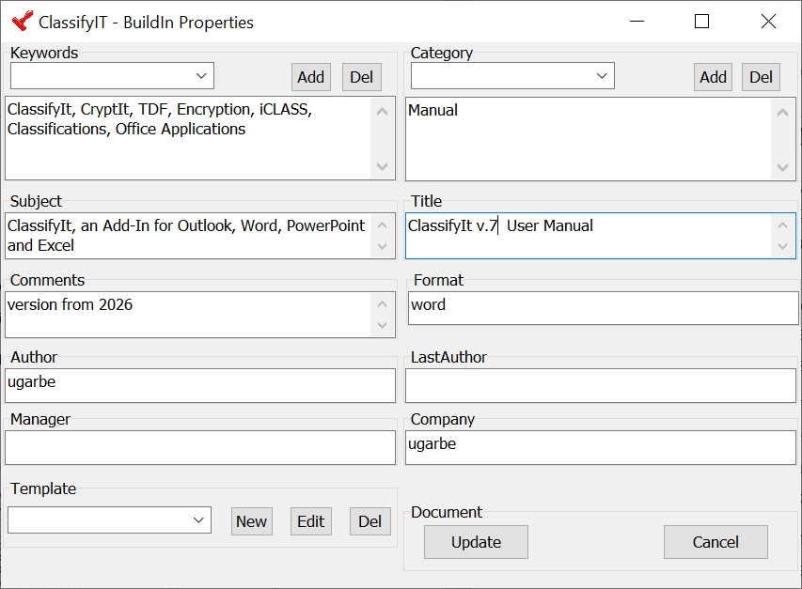

Assign Metadata opens the document properties dialog for the current document. In Word and Excel, users can maintain values such as title, subject, category, keywords, comments and related metadata; PowerPoint uses the same concept where supported by the host application. Predefined keywords and categories can be selected, or free text entered where the configuration permits; using predefined values keeps spelling and terminology consistent across documents, and templates can be used to apply a prepared set of properties to a document.
These properties help search, discovery and reuse. They do not replace the classification marking. The visible classification and the technical iCLASS marking remain the authoritative classification information.
When a document is exported to CI-TDF, ClassifyIt can include its properties as JSON in the separate 0.metadata entry. The signed manifest contains a hash used to verify those properties on import. These properties remain readable in clear text even when the document content is encrypted, so check them before sharing sensitive information.

Release Form
The Release Form is the main ClassifyIt menu for selecting a classification marking that can be applied to the document. You must select one of the classification options and any required Releasable To options. If there are many release options, you can filter for release markings that contain the text you enter in the edit box. There is also an option to Select All; clicking Select All a second time removes all release options. Release Group provides a convenient option for selecting several release options at the same time. This is useful for larger release groups, such as coalitions or alliances.
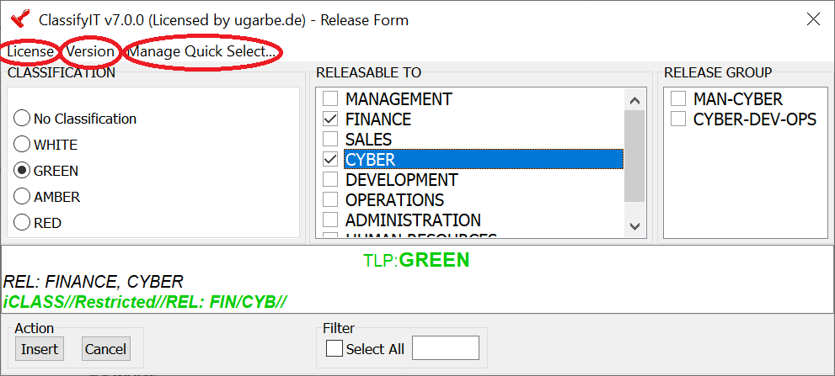
In the top window frame, the version of ClassifyIt is shown, as well as whether the product is licensed and to whom. Additional information is provided under License and Version.

Manage Quick Select allows a user-specific selection and order for the Quick Select menu.
To add a Quick Select option, choose the classification and release options in the Release Form and click the Manage Quick Select button. The Manage Quick Select menu opens. With Add Current, the selected classification and release are added, and you are asked to add a display name (keep it short and precise). In addition, you can select any existing Quick Select marking and edit its name, delete it, or move it up or down in the list.

CryptIt – Word, PowerPoint, Excel
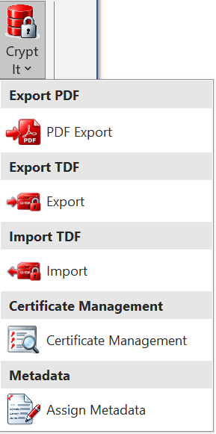
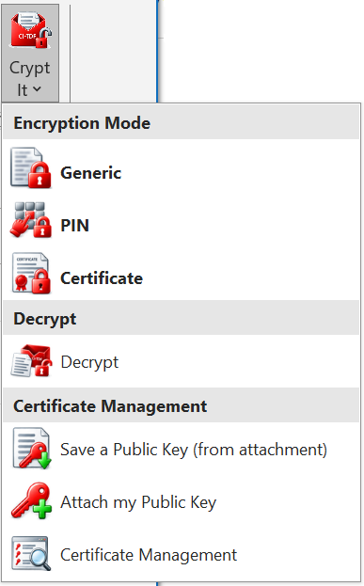
CryptIt is the main encryption menu for documents and email attachments. The menu is slightly different in Outlook and uses the second icon shown.
Word, PowerPoint and Excel provide CryptIt functions to export and import the current document, provide basic key management functions and allow metadata to be integrated into the document. The Outlook CryptIt functions are specialised for email and allow the encryption of attachments, the decryption of attachments and specific and general key management functions.
In Word, PowerPoint and Excel, pressing the upper part of the Crypt It button always starts the Export flow described below and asks for the encryption mode; unlike an email, a document has no persistent encrypted/decrypted state to toggle. The lower part of the button opens the Crypt It menu, which additionally offers PDF Export, Import and Certificate Management.

Export PDF

The Export PDF function creates a PDF version of the current Office document. The document must be saved and classified before export. The PDF is created in the same folder as the source document and normally uses the same filename with the PDF extension.
The visible classification marking remains part of the exported PDF. ClassifyIt also stores the technical classification marking in the PDF metadata so that compatible checking tools can still identify the classification after export.

Export TDF
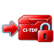
The Export TDF function exports the current Word, PowerPoint or Excel document to a ClassifyIt Trusted Data Format container (CI-TDF). The CI-TDF container preserves the classification assertion and, depending on the selected mode, can also encrypt the document content. If the document has not been saved to disk yet, the export function will prompt you to save it first. The exported TDF file is created in the same folder, using the same file name with .tdf added.
When Export TDF is selected, ClassifyIt asks for the export mode. None creates an unencrypted CI-TDF container with integrity and classification information. Generic uses the preshared certificate built into ClassifyIt, so anyone with ClassifyIt can decrypt it, including users of freeware builds. PIN protects content with a password shared separately with recipients. Certificate encrypts for recipients whose public certificates are available in your local certificate folder; the sender is automatically included so that the sender can also decrypt the export.
Freeware builds create signed, unencrypted CI-TDF containers regardless of the selected encryption mode. Read the encryption notice and check that your installation supports encryption before sending sensitive content. Freeware users can still decrypt supported files created by licensed users.
File limits: the stored payload must not exceed 256 MiB and the restored document must not exceed 512 MiB. If export reports a size limit, reduce the file size or split the content before exporting. If processing fails or is cancelled, the original attachment is retained; a send attempt requiring automatic attachment encryption is blocked until processing completes.
Legacy files: v7 does not decrypt older .cit files. Ask your administrator to recover them using a compatible older ClassifyIt installation and the original keys, then export the recovered content to CI-TDF. Keep the originals until recovery has been checked.

Import TDF
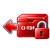
The Import TDF function opens a CI-TDF container and restores the original unencrypted document. If the container is encrypted, ClassifyIt asks for the required decryption information. For PIN mode this is the PIN. For Certificate mode this is the private-key certificate and its password.
After import, ClassifyIt restores the classification from the verified container information. This prevents the user from relying only on the visual text in the document and keeps the technical classification information aligned with the imported content.

Certificate Management
Certificate mode protects content so that only the intended recipients, identified by their certificates, can decrypt it; the sender's own certificate is always included so the sender can also open the protected container later. See Annex A - Certificate Exchange Walkthrough for a complete step-by-step example of generating, exchanging and using certificates.
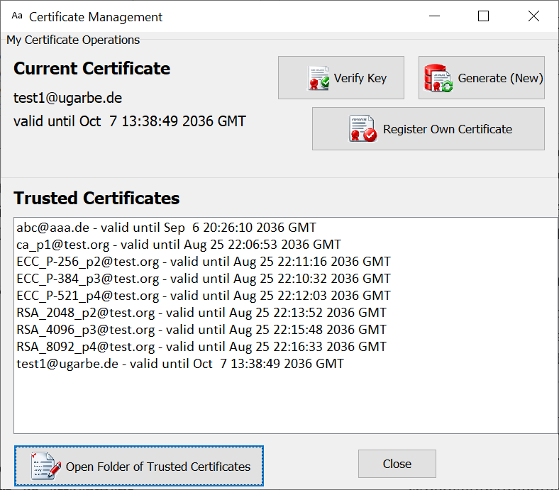

All of the following actions are grouped behind a single entry, Certificate Management, in the Crypt It menu. Selecting it opens a dedicated window for managing your own certificate and the certificates you have received from colleagues.
Current Certificate: the top of the window shows the name and validity of the certificate you are currently using, so there is no need to open the certificate file itself to check this.
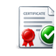
Verify Key: checks that the stored private key matches your certificate and that the password you enter is correct.


Generate (New): creates a new public-private key pair and certificate, replacing the current identity. The private key is protected by a password. Before replacing an identity, back up its certificate and private key securely and retain the password: older encrypted files still require the corresponding old private key.

Register Own Certificate: lets you select an existing certificate together with its matching private key (.pem, .crt or .cer). If the certificate is already in the certificate store, it is simply activated; otherwise it is imported first and then activated.

Trusted Certificates: the list below the buttons shows every certificate you have received from colleagues, together with its validity, so you can check whose public key is available before encrypting for them.
Open Folder of Trusted Certificates: opens %APPDATA%\Certificates, which stores your own certificate and private key and the public certificates imported from colleagues. Protect private keys and their passwords, and keep a secure recovery backup.

CryptIt – Outlook
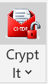
CryptIt in Outlook is the encryption menu for email attachments. Unlike the document-based CryptIt menu in Word, Excel and PowerPoint, it works directly on the attachments of the currently open or selected email, and also provides the key-management entries needed to exchange certificates by email.
The CryptIt split button has two parts. The lower part opens the CryptIt menu, where you first choose an encryption mode - Generic, PIN or Certificate. The upper part then encrypts the current attachments using that mode. Once the attachments are encrypted, pressing the upper part again decrypts them: ClassifyIt detects the current state automatically, so the same button serves for both directions.


Generic Encryption: encrypts attachments using the preshared certificate built into ClassifyIt. Any ClassifyIt installation can decrypt them, including freeware builds. This mode is convenient for broad exchange but is not recipient-specific.

PIN Encryption: encrypts attachments with a PIN chosen by the sender. The PIN must be communicated separately from the encrypted email.
Certificate Encryption: encrypts attachments for the selected recipients' public keys. Only recipients with the matching private key can decrypt the attachments. Certificate files are named after the recipient's SMTP email address - for example, the certificate for surname.name@company.com is named surname.name@company.com.crt.

Encryption
For encrypting attachments, select any of the three modes. When using Certificate Encryption, make sure the recipients are already in the To and/or Cc field, and that you hold the corresponding certificate for each of them in your certificate store.
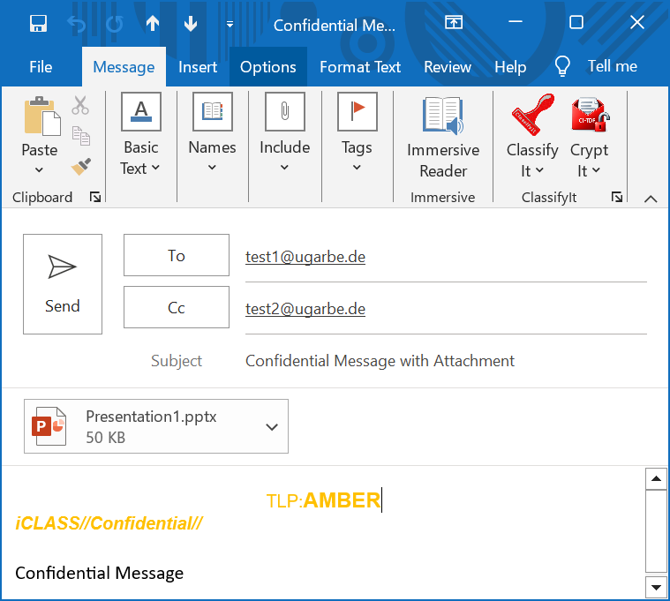
The following example shows how to encrypt an attachment with Certificate Encryption for two users, test1@ugarbe.de and test2@ugarbe.de. For the second user we have not yet received the public certificate, so we will receive a warning message.
The email has a .pptx attachment and the two recipients already added.

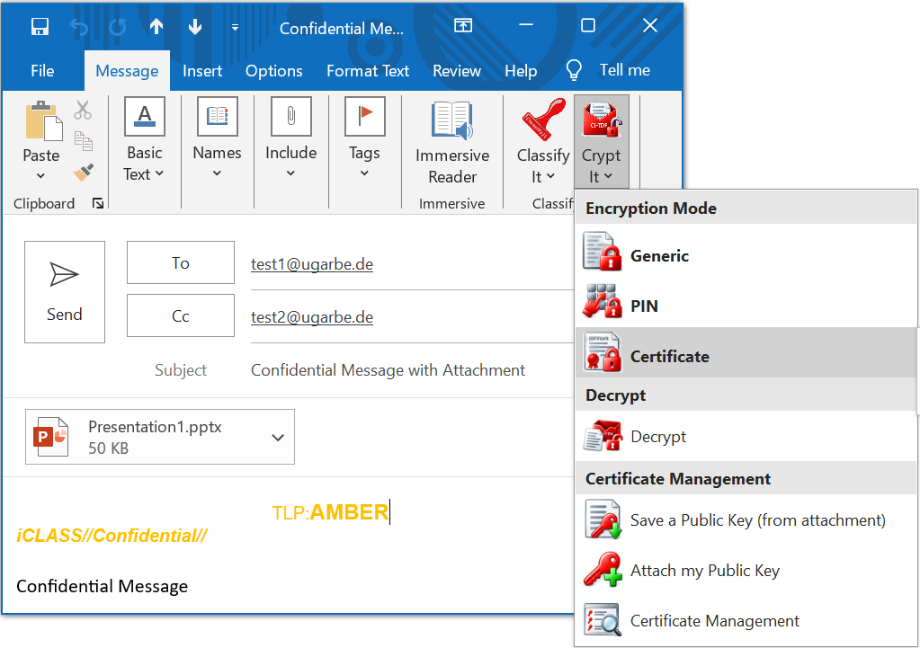
Next, open the Encryption Mode menu and choose Certificate.

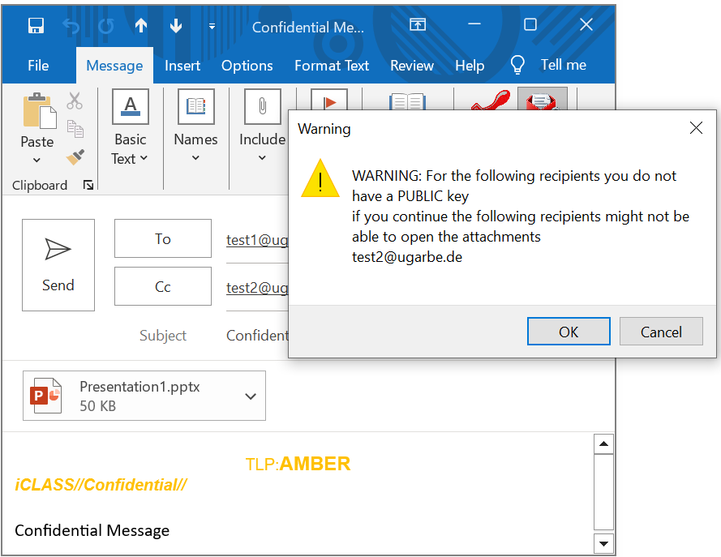
ClassifyIt shows a warning that the public key for test2@ugarbe.de is not available.
Continuing will encrypt the attachment, but test2@ugarbe.de will not be able to decrypt it.

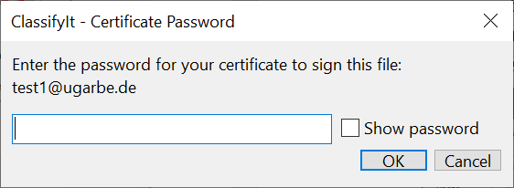
After the warning, enter the password protecting your own private key - in this example, the sender is also test1@ugarbe.de.

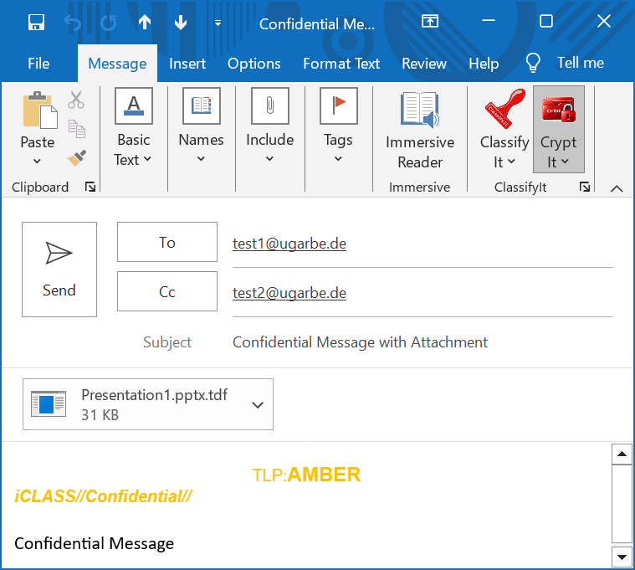
If the password is correct, the attachment is encrypted and can only be decrypted by test1@ugarbe.de.
The CryptIt icon now shows as closed, indicating the attachment is encrypted, and the .pptx file has become a .tdf file.
Adding additional attachments will automatically encrypt those as well.

Save a Public Key
Save a Public Key: imports signed public-certificate packages ending in .crt.tdf and public certificates attached as .pem, .crt, .cer or .public files. ClassifyIt can offer to import an unrecognised certificate when you open the email. Private-key files must not be shared or imported as public certificates.

Attach my Public Key

Attach My Public Key: adds your public certificate as a signed, unencrypted <certificate-name>.crt.tdf package. ClassifyIt may ask for the password protecting your private key to sign the package; the private key itself is never included. Recipients use Save a Public Key to verify and import the public certificate. Organisation-specific mail filtering can still affect delivery.

Public-Private Key Concept - how to use certificates
A public-key certificate contains a public key and identifying information. Its matching private key is stored separately, must stay secret and is protected by a password. Share only the public certificate so that other users can encrypt information for you.
When Bob wants to receive certificate-encrypted data, he generates a certificate, keeps its private key and sends the public certificate to Alice. Alice imports it and encrypts for Bob. Bob can decrypt using his private key and password; ClassifyIt also includes Alice's own certificate so that she can reopen her export.
The public key does not need to be protected as a secret. It can be sent by email or made available through another trusted distribution method. The private key and its password must be protected carefully. If the private key is lost or the password is forgotten, encrypted information for that key can no longer be decrypted.
For regular certificate-based exchange, each participant should generate a certificate, share the public key with communication partners and import the public keys received from others. Once this preparation is complete, certificate mode is reliable and convenient for recurring need-to-know exchange.

PDF Export
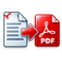 In Word, Excel and PowerPoint, ClassifyIt can export the current document to PDF. The source document must be saved and classified before export. The PDF is created in the same folder as the source document and normally uses the same filename with the PDF extension.
The exported PDF keeps the visible classification marking and stores the technical classification marking in PDF metadata. This supports later checks by ClassifyIt and by compatible DLP or inspection tools.

Word Paragraph Marking
Paragraph marking is a beta feature and should only be enabled by the administrator in test environments. When enabled, Word shows paragraph marking commands in the ClassifyIt menu. Selected paragraphs can receive individual markings in addition to the document classification. Keep paragraphMarking disabled for production deployment.
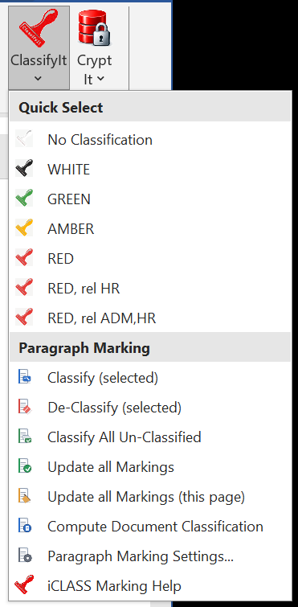
Figure 5-1. Word ClassifyIt menu with paragraph marking commands enabled.
 Classify selected paragraphs: applies a paragraph classification to the current selection.
 Classify all unmarked paragraphs: adds paragraph markings where no paragraph marking is currently present.
 Clear paragraph markings: removes paragraph markings from the selected paragraphs.
 Refresh paragraph markings: updates the visible paragraph markings in the document.
 Document classification from paragraphs: calculates or verifies the document classification based on paragraph markings where this is enabled by policy.
 Paragraph settings: opens the paragraph marking settings dialog.
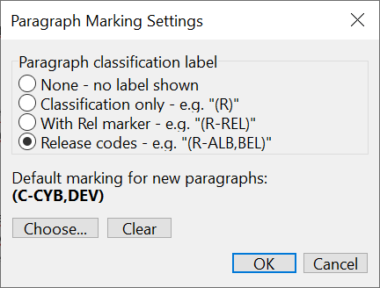
Figure 5-2. Paragraph marking settings.
Paragraph markings are shown beside the relevant paragraph in a compact iCLASS-style notation. Depending on policy, release codes can be hidden, shown generically, or shown with the actual release markings.
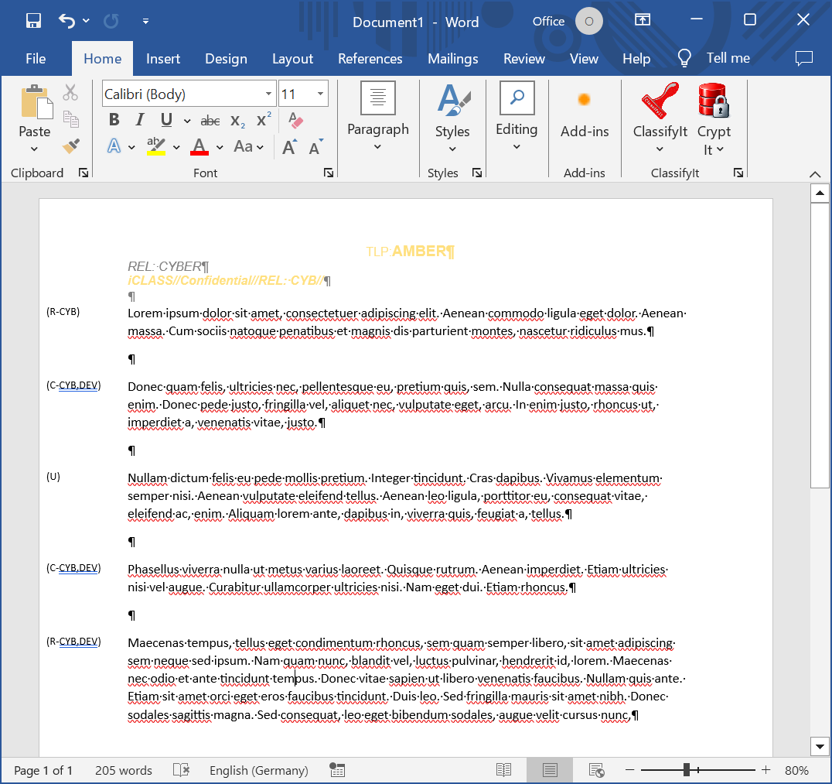
Figure 5-3. Example Word document with paragraph markings.

Outlook Behaviour

Email Without a Classification
Depending on the configuration, Outlook emails may not be sent without a classification. If the user tries to send an unclassified email, ClassifyIt informs the user and opens the classification menu so that a valid marking can be selected.
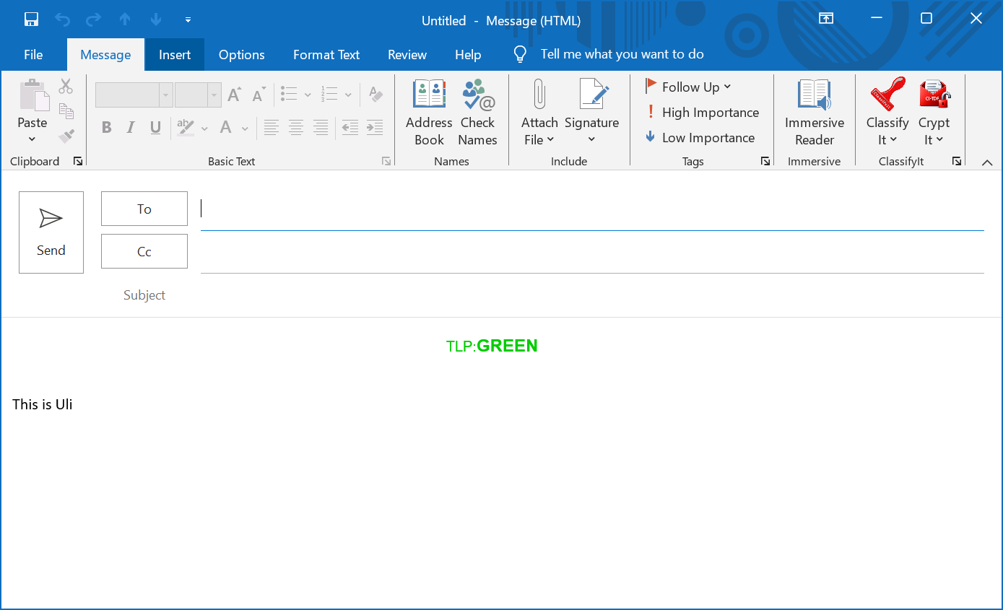
Figure 6-1. New Outlook email with the ClassifyIt menu available.

Quick Select in Outlook
Quick Select provides shortcuts for frequently used markings. The entries are configured by the organisation and can also be adjusted by the user where this is allowed. Selecting an entry immediately applies the corresponding classification and release marking.
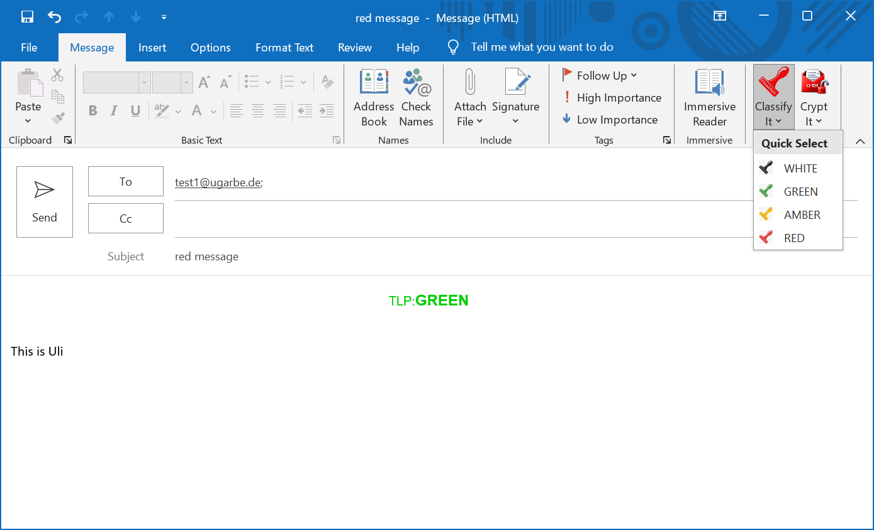
Figure 6-2. Quick Select menu used to apply a frequently used marking.

Email With Unapproved Attachment Type
ClassifyIt can block or warn about attachment file types that are not authorised by policy. If a user attempts to send an email with an unapproved attachment type, ClassifyIt displays a message identifying the attachment that must be removed or replaced.

Reply or Forward with Lower Classification
When replying to or forwarding an email, ClassifyIt can compare the new email classification with the original email and its attachments. Depending on policy, a lower classification can either trigger a warning or block sending until the classification is corrected.
If attachment checking is enabled, ClassifyIt can also compare the email classification with the classification of attached Office documents and exported PDFs. This helps prevent sending an email whose marking is lower than the information it contains.

Annex A – Certificate Exchange Walkthrough
This annex walks through a complete certificate exchange between two colleagues, Alice and Bob, from generating their certificates to encrypting a document for each other. It builds on the concepts introduced in Public-Private Key Concept - how to use certificates, and on Certificate Management described under CryptIt.

Step 1 – Alice Generates Her Certificate
Generate (New): Alice opens the Crypt It menu (in Outlook, Word, Excel or PowerPoint) and selects Certificate Management. In the Certificate Management window she clicks Generate (New). ClassifyIt creates a new public-private key pair and asks Alice for a password that will protect her private key.
Alice chooses a strong password and keeps a secure backup of her certificate, private key and recovery information. Losing the key or password can make files encrypted for that key inaccessible. Her new certificate is now shown as Current Certificate.

Step 2 – Alice Sends Her Public Key to Bob
Attach My Public Key: in a new email to Bob, Alice selects Attach My Public Key from the Crypt It menu. ClassifyIt creates a signed, unencrypted .crt.tdf certificate package and may request her private-key password to sign it. Only her public certificate is attached; her private key remains on her computer.
Alice sends the email to Bob. The public key is safe to send this way: only the matching private key, which never leaves Alice's computer, can decrypt information encrypted with it.

Step 3 – Bob Imports Alice's Public Key
Save a Public Key: when Bob opens the email, ClassifyIt can offer to import Alice's .crt.tdf package; alternatively, he selects Save a Public Key (from attachment) in the Crypt It menu. ClassifyIt verifies the package before copying the public certificate into the local certificate folder.
Alice's public certificate appears in Bob's Trusted Certificates list together with its validity. A valid package signature proves that the package matches the enclosed signing certificate; confirm the certificate owner's identity through your organisation's trusted exchange procedure before relying on it.

Step 4 – Bob Generates His Certificate and Sends It to Alice
Bob repeats Step 1: he opens Certificate Management and clicks Generate (New) to create his own certificate and password. He then repeats Step 2, attaching his public key to an email to Alice using Attach My Public Key. When Alice receives it, she imports it the same way Bob did in Step 3, either automatically or via Save a Public Key (from attachment).
Alice and Bob now hold their own password-protected private keys and each other's public certificates. They can reuse these certificates for subsequent exchanges, but must exchange updated public certificates when identities are replaced or renewed.

Step 5 – Alice Encrypts for Bob Using Certificate Encryption
Certificate: in Outlook, Alice adds Bob to the email recipients and selects Certificate mode. For a Word, Excel or PowerPoint export, she selects Bob's certificate in the recipient-selection dialog. Bob's certificate, received from him in Step 4, is now available.
In Outlook, Alice attaches the file(s) she wants to protect and then presses the upper part of the Crypt It button to encrypt the attachments. In Word, Excel or PowerPoint, the same Certificate mode is used with Export instead, to protect the current document as a CI-TDF container. Alice sends the encrypted email or container to Bob.

Step 6 – Bob Decrypts Alice's Message
Bob opens the email and presses the upper part of Crypt It to decrypt its attachments, or uses Import for a CI-TDF document. His matching private key and password unlock the content. ClassifyIt automatically included Alice's certificate during encryption, so she can also decrypt with her own private key and password. Other recipients need a private key corresponding to a certificate included when the file was encrypted.
Once this one-time exchange of public keys is complete, Alice and Bob can repeat Steps 5 and 6 as often as required, in either direction, without exchanging keys again. If either certificate is replaced (for example, after Generate (New) is used again) or expires, the exchange in Steps 1 to 4 must be repeated before Certificate mode can be used between them again.

