
ClassifyIt 7.0
ADMIN GUIDE
ClassifyIt, an Add-In for Outlook, Word, Excel, PowerPoint

support@ugarbe.de
2026
Table of Contents
Article I. Overview 5
(a) Preparation Phase 6
(b) Deployment Phase 7
Article II. Installation 8
Article III. Initialisation Process 9
Article IV. Prepare ClassifyIt 10
Section 4.01 Configuration of ClassifyIt.json 10
Section 4.02 Integrity of Configuration-File (ClassifyIt_ConfigSigner) 11
Article V. Configuration 12
Section 5.01 Introduction 12
Section 5.02 Registry and Configuration File 12
Section 5.03 Registry Keys 13
(a) Description: 13
(b) Example: 13
Section 5.04 Configuration File 14
Article VI. ClassifyItUserData.json 28
Section 6.01 "categories" 28
Section 6.02 "keywords" 28
Section 6.03 "templates" 28
Section 6.04 "ECC" 28
Section 6.05 "quickSelect" 29
Article VII. Manual Installation 30
Section 7.01 Registering ClassifyIt.dll 30
Section 7.02 Deregister ClassifyIt.dll 30
Section 7.03 Link ClassifyIt.json file 30
Article VIII. Classification Properties (X-Header Information) 32
Article IX. Data Leak Protection (DLP) 33
Article X. Prevent Disabling of ClassifyIt 34
Section 10.01 Prevent ClassifyIt being disabled by a user 34
Section 10.02 Ensure ClassifyIt is loaded at all times 35
Article XI. Information Manager 36
Section 11.01 Classifications 37
Section 11.02 Release Markings 38
Section 11.03 Release Groups 38
Section 11.04 Quick Select 39
Section 11.05 Default Marking 40
Section 11.06 Formatting 40
Article XII. iCLASS 41
ClassifyIt 7.0 – Administrator Guide

This document is for administrators to manage and distribute ClassifyIt. It contains installation aspects to understand how ClassifyIt behaves during boot time and where it expects its configuration parameters to enforce your classification markings to Office documents.

The reader should start with the Overview which provides a step-by-step best practice guide of configuring and deploying ClassifyIt linking to the important chapters. Many details in later chapters are of less importance for a typical deployment, as support is given by support@ugarbe.de, for initial installations and later if subscription is active.

ClassifyIt is an Add-In for Outlook, Word, PowerPoint and Excel of the Microsoft Office 2010 Suite and later products. The main testing has been conducted on the Office 2019 Suite. Compatibility should be with higher versions from Office 2010 onwards. Office 365 and Microsoft 365 versions should be compatible provided the Windows based version is installed (web-based versions will not work).

ClassifyIt is SHAREWARE software and must be licensed when used after the test-period. The normal test-period is 3 months however, longer test-periods can be granted if requested. Please contact us at: support@ugarbe.de

Before deploying ClassifyIt, conduct thorough technical integration and user testing in your reference environment. Focus should be given to add-in integration and potential incompatibilities with other add-ons.

Overview

The following describes a typical best practice installation path of ClassifyIt. Whenever problems or questions occur, please contact your support team at: support@ugarbe.de

Please note that most details of this document are not required by your team for a typical ClassifyIt deployment. The deployment is an interactive process between your administrator and support@ugarbe.de. The deployment is straightforward and requires an administrator of your Windows and/or Microsoft Office installations and for the security markings an information management expert (or someone who understands the classification markings of your company/organisation).

In any case – test ClassifyIt thoroughly before deploying it operationally.

Preparation Phase
The preparation has the aim of establishing the base configuration of your ClassifyIt implementation and consider how to deploy ClassifyIt to your users.
During this phase technical administrator knowledge and information management knowledge is necessary.
# | Who | What
1 | Administrator | Familiarise with installation details:  - Article II Installation  - Article III Initialisation Process
2 | Information Manager | Provide details of classifications:  See Article XI Information Manager  - Provide some examples of classification markings;  - Provide list of classifications;  - Provide list of release markings (optional);  - Consider release groups (optional);  - Provide default classification and release marking (this will be added to a new document/email by default);  - Consider the most commonly used classification and release markings (used for quick select);
3 | Administrator | Consider Data Leakage Protection (DLP) options:  - ClassifyIt encodes the classification and release marking of each email in the X-Header and for documents in a custom property. Gateway and mail-servers can set inspection rules to allow, reject or log the sending of emails or copy-pasting of documents. As such you could reject sending higher classified information without encryption, or restrict the distribution without release markings, or … .
4 | Administrator | Finalise the configuration:  - Contact support@ugarbe.de with the details from the Information Manager (#2);  - ugarbe.de will provide you with the configuration file;  - Test the received configuration and coordinate with the Information Manager if things need to be changed/updated;  - Finalise the configuration in coordination with support@ugarbe.de;

Deployment Phase
The administrator needs to decide how to deploy ClassifyIt to the users’ workstations. It is recommended to use the same deployment as used for the Microsoft Office.
Running the ClassifyIt setup program installs the ClassifyIt add-on to Office on the workstation where executed. For mass deployment:
# | What
1 | Deploy the plug-in:  - Copy the ClassifyIt.dll to a folder on the users’ workstations;  Example: %PROGRAM FOLDER%\ClassifyIt\
2 | Register the plug-in:  - Execute the following command in the command shell with administrator rights: regsvr32 "<FOLDER>\ClassifyIt.dll"  Example: regsvr32 "C:\Program Files\ClassifyIt\ClassifyIt.dll"
3 | Deploy the ClassifyIt.json configuration file:  - Consider a network share or a web-server, where the configuration file is stored for the ClassifyIt plug-in. ClassifyIt loads the configuration file during the startup of the Office application (Outlook, Word, PowerPoint, Excel). Two file locations should be selected, so if the primary location is not reachable, the secondary will be used;  - Deploy the ClassifyIt.json configuration file to the two locations, <LOCATION_1> and <LOCATION_2>
4 | Register the locations of the configuration file on the key:  \HKEY_LOCAL_MACHINE\SOFTWARE\CLASSIFY_IT  - Entry: ConfigFile  Type: REG_SZ  Value: <LOCATION_1>  - Entry: AlternateConfigFile  Type: REG_SZ  Value: <LOCATION_2>  Examples for Value:  - C:\Program Files\ClassifyIT\ClassifyIt.json  - http://ugarbe.de/ClassifyIt.json
5 | Ensure ClassifyIt cannot be disabled by Users or Office  Set the registry keys as described in Article X Prevent Disabling of ClassifyIt

Installation

Before installing ClassifyIt, please ensure that the version of Microsoft Office and ClassifyIt match. Microsoft Office can be installed as a 64-bit version or 32-bit version. ClassifyIt has to be of the same version as your Office installation, otherwise ClassifyIt will not be able to be executed! To verify, open any of the Office applications, like Word, and do the following:

In Office 2010 verify with:  File Help | 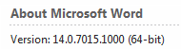
In Office 2016 verify with:  File Account About Word | 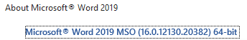

Before installing ClassifyIt, please ensure that all Office applications are closed to permit ClassifyIt to properly register as an Add-In to Outlook, Word, Excel and PowerPoint. The registration could fail if any of the applications is still running. If you encounter problems please check with the Windows TaskManager if really all Office applications are closed, and if required end the application through the TaskManager – afterwards reinstall ClassifyIt.
Start the installation by executing the provided setup program.
During the installation process the ClassifyIt Add-In application and configuration files are installed in the %PROGRAM FOLDER%\ClassifyIt directory (e.g. C:\Program Files\ClassifyIt). This is the program directory of the setup program. For mass deployment using other deployment means, the directory can be different.
After the installation the Add-In is directly usable, however the configuration file (default: ClassifyIt.json) must be changed to support the classification requirements of your organisation/company. If help is needed, please see section Configuration or contact support@ugarbe.de.
After the installation the ClassifyIt toolbar is available on all open or newly created emails, Word documents, Excel spreadsheets and PowerPoint presentations.

Initialisation Process

The ClassifyIt Add-In is a library which runs in the Microsoft Office context, as such it is programmed as a Dynamic Link Library (DLL). After the installation (running the setup executable) this add-in is in the following file:
%PROGRAM FOLDER%\ClassifyIt\ClassifyIt.dll
Note: it is possible to change the folder and the name of the DLL – in this case the registration of the ClassifyIt.dll needs to be done using the ‘regsvr32’ Windows command.
Note: with v7 OpenSSL libraries are part of the installation package. Those two following dll files must be in the same folder as the Classifyit.dll:
libcrypto-3-x64.dll, libssl-3-x64.dll

When the ClassifyIt Add-In is started (within the Office context) it needs to load its configuration file, which is formatted in a JSON syntax – by default the configuration file is the following file:
%PROGRAM FOLDER%\ClassifyIt\ClassifyIt.json
The file-name and location of the configuration file is set by the Registry key HKEY_LOCAL_MACHINE\SOFTWARE\CLASSIFY_IT\ConfigFile – the key can be a URL or file-system path.
When the ClassifyIt Add-In starts for the first time (e.g. by starting Outlook, Word, Excel or PowerPoint) the following files are created under the users CSIDL_APPDATA folder (e.g. C:\Documents and Settings\username\Application Data\Roaming):
- ClassifyItUserData.json
Used for ClassifyIt User Data
- ClassifyIt.log
Used for logging information of ClassifyIt
- ClassifyIt.json
local copy of the configuration file. This file is overwritten whenever the applications are started (Outlook, Word, Excel, PowerPoint) and the central configuration file is available.
- Certificates
folder storing user’s digital certificate (private and public key) and recipients public keys, needed for the CryptIt module.

Prepare ClassifyIt

Note: For a typical best-practice installation the details of this chapter are not important, as ugarbe.de provides all input. This chapter is a technical reference for those who procured the signature tool and want/have to configure ClassifyIt themselves.

After the installation there are 2 steps which need to be done. First the configuration file ClassifyIt.json needs to be adjusted to the required classification schema and second, the updated configuration file must be signed. Both steps are to be done by an administrator. The adjustment of the configuration file is most critical, contact support@ugarbe.de whenever in doubt or if problems are encountered.

Configuration of ClassifyIt.json
The adjustment of the ClassifyIt.json configuration file is the most critical step in your deployment of ClassifyIt. The syntax of the JSON file is sensitive and must be absolutely correct, otherwise ClassifyIt will not work properly. The configuration, based on your requirements, will typically be done by ugarbe.de. The JSON file is signed to ensure its integrity, so that no-one else can change your classification schema. If you do the configuration yourself, please ensure you have the signature tool procured.
To make your own configuration file you could use the following guidelines:
- understand your classification schema;
- use an editor which understands the JSON format, for instance Notepad++ with the JSON Viewer plugin;
- start with the original configuration file and adjust it in small steps to understand the changes;
- most Office applications must be restarted to read the new configuration file. But in Outlook there is the possibility to use the admin_mode, then in Outlook the configuration file can be reloaded through an extra button in the menu;
- check the JSON format with a tool (see b);
- sign the JSON file (see next section)
- test the configuration thoroughly.

Integrity of Configuration-File (ClassifyIt_ConfigSigner)
The ClassifyIt.json configuration-file has a tamper protection to ensure its integrity through a signature, so that only authorised persons can change the configuration. The signature value is verified by the ClassifyIt plug-in when the configuration-file is loaded. The signature value must be calculated by the ClassifyIt_ConfigSigner.exe. This signing application is usually only used by ugarbe.de. Only in exceptional cases it is useful for the customer to procure the signer tool.
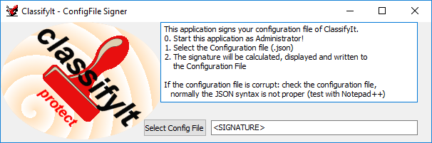
- Start the ClassifyIt_ConfigSigner application (the application might have to be executed with administrator privileges, if the configuration file is in a protected folder, like a program folder).
- At startup, load the authorised signing private key and its matching certificate. The signing key must match the configuration-verification certificate embedded in the deployed ClassifyIt add-in; an arbitrary certificate will not be accepted. Agree key provisioning with support@ugarbe.de. Keep the private key and its password restricted to authorised administrators, maintain a protected recovery backup, and coordinate any replacement with an update of the verifier in the add-in.
- Select the configuration-file.
- The configuration file gets properly signed and a success message is shown.
- If signing fails, check the reported error, JSON syntax, signing key/certificate pair, password and file permissions. Correct the cause and sign again. Test the signed configuration with the deployed add-in before rollout.

Configuration

Introduction
The proper configuration of the tool is the most critical and requires most attention during the deployment of ClassifyIt.

Registry and Configuration File
ClassifyIt is controlled by a Registry Key and a Configuration-File:
1. Locator of Configuration-File
1. Registry Key: HKLM\SOFTWARE\CLASSIFY_IT [holds two values with the path or URL and name to the Configuration-File]
Note: for the 32-bit version of ClassifyIt the key is stored at: HKLM\SOFTWARE\Wow6432Node\CLASSIFY_IT
1. ConfigFile: [first try of ClassifyIT Add-In to load the Configuration-File]
2. AlternateConfigFile: [alternative if file specified by ConfigFile does not exist, is not reachable or is corrupt]
- Configuration-File
<classifyIt.json> [holds all configuration parameters of ClassifyIt in a JSON formatted file]

Registry Keys
HKLM\SOFTWARE\CLASSIFY_IT\
Two keys specify the fully qualified file-name of the <classifyIt.json> file.
ConfigFile=<PATH\FILE_NAME> or <URL>
AlternateConfigFile=<PATH\FILE_NAME> or <URL>

Description:
The ConfigFile key specifies the preferred location of the <classifyIt.json> file. If the preferred file is not available (or corrupt) the alternative configuration file will be loaded during the start of Outlook, Word, PowerPoint or Excel. The configuration file could be on a local or shared drive, or on a web-server where the URL is to start with 'HTTP://'.
If no configuration file is available, ClassifyIt will try to load a previous copy of the configuration file in the user’s CSIDL_APPDATA folder.
If none of the files is available then an error message is displayed to the user. If any of the files is not available or corrupt, an error/warning is written in the classifyit.log file.
Note: A configuration file is corrupt if either the JSON syntax is incorrect, or if the integrity of the file (provided through ClassifyIt_ConfigSigner.exe) is incorrect.

Example:
ConfigFile='http://classifyit.eu/ClassifyIt.json'
AlternateConfigFile='c:\configData\classifyit.json'

Configuration File
The <classifyIt.json> file controls content and behaviour of the ClassifyIt Add-In.
Note: The standard setup uses the filename: “ClassifyIt.json”, however any other name can be used as specified by the Registry (see Section 5.03).
The following describes the Format and then the different sections within the configuration file.

Encoding
Save configuration files as UTF-8. Existing UTF-16 little-endian files with a byte-order mark can also be read.
Use a Unicode-aware JSON editor so that special characters remain correct, and re-sign the configuration after every change.

Format
The configuration file is JSON formatted (www.json.org/). This is a very efficient, powerful, text-based and human readable format.
It is important that the syntax of the configuration file is fully JSON compliant. Use a syntax checking editor to modify or generate the configuration file (e.g. Notepad++, notepad-plus-plus.org/, with a JSON plug-in, nppjsonviewer).

"classifyit_control"
Is a record of values controlling the overall behaviour of ClassifyIt:
"admin_mode" <boolean> specifies if in Outlook the configuration file can be reloaded, which might be useful during the creation of the configuration file by the administrator.
"use_default_marking" <Boolean> specifies if in Outlook a default marking should be put on emails when generated. The other applications automatically add the default marking when a new document is generated.
"default_marking" <RECORD> specifies the default classification and release marking assigned to new documents/emails, using the same "class" and "rel" fields described below (the same convention used throughout this file - see "classifications", "release_markings" and "quickSelect").:
"class" <STRING> classification value which must match one of the "class" values in the "classifications" section.
"rel" <ARRAY of STRING> release marking value(s) which must match "rel" values in the "release_markings" section; use an empty array [] if no release marking applies.
"originator" <STRING> (new in ClassifyIt 7.0) short originator code (e.g. an ISO 3166 alpha-3 country code, or an organisational code/name). This will be embedded as the classification assertion's "org" value when exporting/encrypting a document to a CI-TDF container. If not specified, a fixed default is used. (Part of iCLASS standard).
"propertyKeyName" <STRING> (change from Classifyit 7.0 onwards) the name of the key in document properties and email x-header, which stores the classification-release value. ClassifyIt is optimised for the “iCLASS” standard, which is the default value. ClassifyIt will still use the iCLASS standard to represent classification and release.
"form_Layout" <STRING> defines the layout of the Release Form. Default is the full selection of the classification and release options. If set to “CLASS” the window shows only the classification selection.

Example:
"classifyit_control":
{"admin_mode": true,
"use_default_marking": true,
"default_marking": {"class": "R", "rel": []},
"originator": "ugarbe.de",
"propertyKeyName": "iCLASS",
"form_Layout": "normal"}

"version_control"
This object defines the date, time, version number and signature of the configuration file. The signature is generated by ClassifyIt_ConfigSigner and verified when the configuration is loaded (see Section 4.02).Section 4.02
"date" <STRING> date of the configuration file.
"time" <STRING> time of the configuration file.
"versionNumber" <STRING> version number of the configuration file.
"signature" <STRING> contains the Base64-encoded configuration signature generated by ClassifyIt_ConfigSigner.exe. Recalculate it whenever the configuration changes. The example below contains a placeholder, not a valid signature; sign the completed configuration before use. The signing tool and authorised private key are available separately and must be restricted to authorised administrators.
Example:
{"date": "2026 10 21",
"time": "220415",
"versionNumber": "7.0",
"signature":"REPLACE_WITH_GENERATED_BASE64_SIGNATURE"}

"classifications"
Is a list of objects which define each available classification. Each classification is defined through the following attributes:
"real" <STRING> the real classification name as it will appear on the document or email when selected, and used as the fallback label if "display" is not specified.
"display" <STRING> (optional) the caption shown for this classification in the ReleaseForm's classification picker; if not specified, "real" is used instead.
"additional"<STRING> text which might be required in addition to a classification.
"trans" <STRING> the translated classification name as it will appear on the document (email) when the classification is selected and when a translation is required (controlled through “requiresTranslatedLabel” of the "classification_formatting" settings). Translation should be used for an interoperable iCLASS label (used in default configurations).
"color" <STRING> the color value (RGB) of the classification.
"class" <STRING> the classification code stored in the marking property (replaces the legacy "x-class" name; the property name itself is set by "propertyKeyName" in the "classifyit_control" section).
"descr" <STRING> a description of the classification which will be shown in the ClassifyIt classification menu as a 'hint'.
"enabled" <BOOLEAN> defines if the classification can be selected by the user – this is normally true.
"icon" <STRING> (optional) color of the stamp icon resource used for this classification in the Quick Select menu – possible values are: amber, black, blue, darkgreen, darkred, green, grey, lightgrey, magenta, navy, orange, purple, red, teal, white
"class-level" <INTEGER> (new with version 5.8) defines the classification level of the classification. In earlier versions the classification level was given by the order of the classifications – first lowest level, … last highest level. Now class-level defines this – lower number is a lower classification level and higher number is a higher classification level.
"sensitivity" <STRING> corresponding Outlook sensitivity (Normal=0, Personal=1, Private=2, Confidential=3). The outlook_control setSensitivityLevel value defines if the sensitivity level is actually applied to the email.

Example:
[{"real": "WHITE",
"display": "WHITE",
"trans": "Unclassified",
"color": "0x000001",
"class": "U",
"descr": "information can be distributed without restrictions (subject to copyright restrictions)",
"enabled": true,
"class-level": 1,
"sensitivity":"0",
"icon":"black"}]

"release_markings"
Is a list of objects which define each available release marking. Each release marking is defined through the following attributes:
"real" <STRING> the real release marking as it will appear on the document (email) when selected.
"trans" <STRING> the translated release marking as it will appear on the document (email) when a translation is required (controlled through “requiresTranslatedLabel” of the "classification_formatting" settings).
"rel" <STRING> the release code stored in the marking property (replaces the legacy "x-rel" name, which is still accepted as a fallback if "rel" is absent). For national release use of ISO 3-letter codes is advised (iCLASS Standard)
"descr": <STRING> a description of the release marking which will be shown in the ClassifyIt classification menu as a 'hint'.

Example:
{"real": "MANAGEMENT",
"trans": "MAN",
"rel": "MAN",
"descr": "Senior Management Staff of Company"}

"release_groups"
Is a list of objects which define groups of release markings. Each release marking group is a collection of release_markings. Each release marking group is defined through the following attributes:
"display" <STRING> the display name for the group.
"group" [<STRING>] (list of strings) each value must be one of the "rel" codes of the "release_markings" section (not the "real" display name). The group then represents all the corresponding release markings. Example:
["MAN", "HR"]
"descr" <STRING> a description of the release group which will be shown in the ClassifyIt classification menu as a 'hint'.

Example:
[{"display":"MAN-CYBER",
"group": ["MAN", "CYB"],
"descr": "add release markings for MANAGEMENT and CYBER"},
{"display":"CYBER-DEV-OPS", "group":["CYB", "DEV", "OPS"], "descr":"Cyber, development and operations"}]

quickSelect
A list of objects which define the entries of the Quick-Select Menu of ClassifyIt. The following attributes are defined per quick-select menu entry:
"display" <STRING> the entry shown in the quick-select menu. (Note: should be short and easily remembered).
"marking" <RECORD> defining the classification and release of the quick select entry, using the same "class" and "rel" fields as "classifyit_control"."default_marking" (see Section 5.04(iv)). Two further optional fields: "title" <STRING> shown as the button's ScreenTip, and "descr" <STRING> shown as its SuperTip.

Example:
{"display": "WHITE",
"marking": {
"class": "U",
"rel": []}}

"classification_formatting":
A list of attributes which define the formatting of the construction of the classification text which will be inserted by ClassifyIt. The following attributes define the appearance of the classification. Note that a line break must be inserted through <BR>, do not use \n

"beforeClassification" <STRING> text before the classification.
"beforeClassificationEmail" <STRING> text which is put in front of the classification, but only for Outlook emails.
"beforeClassificationWord" <STRING> text which is put in front of the classification, but only for Word documents.
"beforeClassificationExcel" <STRING> text which is put in front of the classification, but only for Excel sheets.
"beforeClassificationPPT" <STRING> text which is put in front of the classification, but only for PowerPoint slides.
"afterClassification" <STRING> text after the classification.
"beforeAdditionalClassification" <STRING> text before an additional classification, only if the additional marking is not empty.
"afterAdditionalClassification" <STRING> text after an additional classification, only if the additional marking is not empty.
"beforeReleaseStrings" <STRING> text before the release marking, only if the release marking is not empty.
"betweenReleaseStrings" <STRING> text/character between the release markings, only if the release marking is not empty and if more than 2 release markings.
"afterReleaseStrings" <STRING> text after the release marking, only if the release marking is not empty.
"afterCompletedClass" <STRING> text/character after the completed classification and release marking.
"requiresRelAs" <BOOLEAN> (default false) to specify if the "AS" markings defined in the "release_markings" section will be used. (new with version 4.7)

"requiresTranslatedLabel" <BOOLEAN> to specify if a translation of the classification and release markings is added to the overall marking.
"beforeTranslatedClassification" <STRING> <see beforeClassification>
"afterTranslatedClassification": <STRING> <see afterClassification>
"beforeTranslatedReleaseStrings" <STRING> <see beforeReleaseStrings>
"betweenTranslatedReleaseStrings" <STRING> <see betweenReleaseStrings>
"afterTranslatedReleaseStrings" <STRING> <see afterReleaseStrings>
"afterTranslatedCompletedClass" <STRING> <see afterCompletedClass>

The following formatting statements define the formatting of the text:
"formatBeforeClassification" list of formatting attributes for the classification string
"font" <STRING> defines the font style. E.g. "Arial", "Courier", "Times New Roman"
"fontSize" <INT> defines the size of the font
"fontColor" <STRING> the font color value in RGB format. A value of "0x000000" specifies to use the value of the classification in the Section 5.04(v)"classifications". If black should be specified please use 0x000001
"fontStyle" list of <STRING> defining the font style, like "bold", "italic", "underline", ...
"paragraphAlignment" <STRING> alignment of the paragraph, like "left", "center", "right"

"formatClassification" list of formatting attributes for the release marking. (same as formatBeforeClassification)

"formatReleaseMarking" list of formatting attributes for the release marking. (same as formatBeforeClassification)

"formatTranslation" list of formatting attributes for the release marking. (same as formatBeforeClassification)

Example:
{"beforeClassification": "",
"beforeClassificationEmail": "Classification: ",
"beforeClassificationWord": "",
"beforeClassificationExcel": "",
"beforeClassificationPPT": "",
"afterClassification": " ",
"beforeAdditionalClassification": "<BR>",
"afterAdditionalClassification": "<BR>",
"beforeReleaseStrings": "REL TO: ",
"betweenReleaseStrings": "\\\\",
"afterReleaseStrings": "",
"afterCompletedClass": "<BR>",
"requiresRelAs": false,

"requiresTranslatedLabel": true,
"beforeTranslatedClassification": "Einstufung: ",
"afterTranslatedClassification": " ",
"beforeTranslatedReleaseStrings": "FREIGABE AN: ",
"betweenTranslatedReleaseStrings": ", ",
"afterTranslatedReleaseStrings": "",
"afterTranslatedCompletedClass": "<BR>"}

"formatBeforeClassification":
{"font": "Courier",
"fontSize": 12,
"fontColor": "0x000000",
"fontStyle": ["bold"],
"paragraphAlignment": "left"},

"formatClassification":
{"font": "Courier",
"fontSize": 12,
"fontColor": "0x000000",
"fontStyle": ["bold"],
"paragraphAlignment": "left"},

"formatReleaseMarking":
{"font": "Times New Roman",
"fontSize": 10,
"fontColor": "0x005500",
"fontStyle": ["italic", "underline"],
"paragraphAlignment": "center"},

"formatTranslation":
{"font": "Arial",
"fontSize": 7,
"fontColor": "0x550000",
"fontStyle": ["bold", "italic"],
"paragraphAlignment": "right"}

"x_header_config"
This section is no longer read by ClassifyIt 7.0 and can be omitted from the configuration file. The marking property name is now configured via "propertyKeyName" in the "classifyit_control" section (see Section 5.04(iv)), and release codes are stored as a JSON array under "rel" rather than a delimiter-joined string, so "xReleaseCodeDelimiter" no longer applies either.

"xMarkingName" (obsolete) formerly the name of the marking property/X-Header; replaced by "classifyit_control"."propertyKeyName".
"xReleaseCodeDelimiter" (obsolete) release codes are now stored as a JSON array, so no delimiter is needed.

Example:
{"xMarkingName": "Classification",
"xReleaseCodeDelimiter": "-"}

"outlook_control"
A list of attributes which define specific Outlook application behaviour. The following attributes are defined:
"banned_filetypes" [<STRINGS>] (list of strings) defining filetypes which the user is not allowed to send by email. IMPORTANT is to specify the preceding '.' as well.
"allowLowerClassification" <BOOLEAN> specifies if a forward or reply to an email could have a lower classification than the original email.
"warnLowerClassification" <BOOLEAN> specifies if, for a forward or reply to an email with a lower classification than the original email, the user should get a warning message. This setting is only effective if “allowLowerClassification” is true.
"allowLowerAttachmentClassification" <BOOLEAN> controls whether the email classification may be lower than the classification of an inspected attachment. If false, sending is blocked when an inspected attachment has a higher classification or has no valid marking. The check covers supported Word, Excel and PowerPoint files, and PDFs carrying the ClassifyIt marking; it does not inspect the contents of every attachment format or a TDF payload.
"warnLowerAttachmentClassification" <BOOLEAN> displays a confirmation warning when allowLowerAttachmentClassification is true and an inspected attachment has a higher classification than the email or has no valid marking. The user can cancel sending or explicitly continue.
"automaticallyEncryptAllAttachments" <BOOLEAN> applies Generic protection to attachments that are not already .tdf or .cit files. Recipients need ClassifyIt to decrypt Generic files, but decryption does not require a licensed build. Cancelling or failing attachment processing blocks the send attempt. The extension check does not establish that an existing container is encrypted. In freeware builds, exports are unencrypted, signed CI-TDF containers regardless of the selected mode.
"markSubject" <BOOLEAN> specifies if the classification should be added in the Subject line of the email. If true the classification will be shown within [ ] brackets.
"markSubjectWithRealName" <BOOLEAN> specifies if the subject marking uses the real name of the classification or the xClassification.
"setSensitivityLevel" <BOOLEAN> specifies if ClassifyIt will change the Email Sensitivity field.

Example:
{"banned_filetypes": [".dll", ".exe", ".bat"],
"allowLowerClassification": true,
"warnLowerClassification": true,
"allowLowerAttachmentClassification": false,
"warnLowerAttachmentClassification": true,
"automaticallyEncryptAllAttachments": false,
"markSubject": false,
"markSubjectWithRealName": true,
"setSensitivityLevel": false}

"word_document_control"
A list of attributes which define for the Microsoft Word application where the classifications should be added and if those are to be enforced. The following attributes are defined:
"addToHeader" <BOOLEAN> if true the classification will be added to the header of the document.
"addToFooter": <BOOLEAN> if true the classification will be added to the footer of the document.
"enforceMarking": <BOOLEAN> specifies if the user can save or print Word documents without a security marking. If set to true the document must have a security marking.
"paragraphMarking": <BOOLEAN> specifies if the user can mark individual paragraphs in the Word document. THIS FEATURE IS IN BETA STATUS AND SHOULD ONLY BE USED IN TEST ENVIRONMENTS. For production this value shall be false

Example:
{"addToHeader": true,
"addToFooter": true,
"enforceMarking": false,
"paragraphMarking": false}

"excel_control":
A list of attributes which define for the Microsoft Excel application where the classifications should be added. The following attributes are defined:
"addToHeader" <BOOLEAN> if true the classification will be added to the header of the document.
"addToFooter" <BOOLEAN> if true the classification will be added to the footer of the document.
"enforceMarking" <BOOLEAN> specifies if the user can save or print Excel sheets without a security marking.

Example:
{"addToHeader": true,
"addToFooter": true,
"enforceMarking": true}

"powerPoint_control":
A list of attributes which define for the Microsoft PowerPoint application where the classifications should be added. The following attributes are defined:
"enforceMarking" <BOOLEAN> specifies if the user can save or print PowerPoint slides without a security marking.
"posLeft" <INTEGER> specifies the left position of the classification text on the slide.
"posTop" <INTEGER> specifies the top position of the classification text on the slide.

Example:
{"enforceMarking": true,
"posLeft": 50,
"posTop": 200}

"crypto_control":
A list of attributes which define if the CryptIt functionality is available, allowing the export of documents to encrypted Trusted Data Format (TDF) containers, and if email attachments could be encrypted to TDF containers. By default this should be enabled:

"allowEncryption" <BOOLEAN> if true CryptIt is enabled.

New in ClassifyIt 7.0: encryption to a CI-TDF container is also available directly from Word, PowerPoint and Excel documents (not only Outlook email attachments), via the 'Crypt It' ribbon menu's 'Export' item. The same 'allowEncryption' setting above also controls whether this Word/PowerPoint/Excel Crypt It menu is shown.
Selecting 'Export' prompts the user for one of four encryption modes and creates a CI-TDF container (named <original file name>.tdf) alongside the source document:
'None' - exports the classified document unencrypted (only signed and tagged with its classification).
'Generic' - uses the preshared certificate built into ClassifyIt. Any ClassifyIt installation can decrypt the content, including freeware builds; this mode is not recipient-specific.
'PIN' - encrypts with a user-supplied PIN (at least 8 characters is recommended); the PIN must be communicated to the recipient out-of-band.
'Certificate' - encrypts to the selected recipients' registered public-key certificates and automatically includes the sender's own certificate, so each included private-key holder can decrypt.
Document properties (Title, Subject, Category, Keywords, Comments, Author, etc.) are stored as JSON in the separate 0.metadata entry of the CI-TDF ZIP container. The signed manifest contains the metadata hash, which is verified during import. Metadata is stored in clear text even when the document payload is encrypted; include only properties appropriate for disclosure.
The same menu's 'Import' item decrypts a .tdf container and re-opens the original document, restoring its classification from the verified container manifest rather than from the file's own internal properties.
The menu's Certificate Management entry opens the common window for generating a certificate/key pair, registering an existing identity, viewing imported public certificates and checking the current certificate. Certificates and private keys are stored in %APPDATA%\Certificates. Outlook's Attach My Public Key command sends a signed, unencrypted .crt.tdf package and may request the sender's private-key password; the recipient imports it with Save a Public Key.
CI-TDF processing limits: the stored payload is limited to 256 MiB and the restored document to 512 MiB. Manifest JSON is limited to 4 MiB and metadata to 16 MiB. PIN imports accept PBKDF2 counts from 100,000 to 2,000,000 iterations; current exports use 600,000. Files exceeding these limits are rejected. Reduce or split oversized source files before exporting.
Upgrade and recovery: ClassifyIt 7.0 does not decrypt legacy .cit files. Before upgrading, retain a compatible older ClassifyIt environment and its required keys, decrypt legacy files there, and re-export them to CI-TDF using v7. Test recovery on representative files and retain the originals until migration is verified.
Freeware builds create signed, unencrypted CI-TDF containers even if an encryption mode was selected, and display a notice for explicit export/encryption actions. Decryption remains available independently of licensing. Verify the deployed build and licensing before enabling a policy that requires encryption.
Example:
{"allowEncryption": true}

ClassifyItUserData.json
This file is located in the users' roaming Application Data directory ( CSIDL_APPDATA, typically: C:\Documents and Settings\username\Application Data\Roaming).
If not existing, the file is created by ClassifyIt during its startup. The file is edited by ClassifyIt when the user adds or removes preferences to the content of some functions. The file can be edited, however it is important that a JSON compliant file is created/maintained, otherwise ClassifyIt will not work properly.
The following sections are defined in the ClassifyItUserData.json file:
In Word Application – ClassifyIt Property Menu:

"categories"
"categories" An array of strings which can be selected for adding categories to the CATEGORIES_PROPERTY
Example: "categories": ["CONTRACT", "INVOICE", "REPORT"]

"keywords"
"keywords" An array of strings which can be selected for adding keywords to the KEYWORDS_PROPERTY
Example: "keywords": ["TEMPLATE", "DOCUMENT"]

"templates"
"templates" An array of records which the user can use to add multiple properties to all property fields. Each template has a unique name.
Example: "templates": [
{"templateName":"Temp1",
"subject": "Subject",
"title": "Title",
"keywords": "Keyword1, Keyword2",
"category": "Cat1, Cat2",
"comments": "Comment",
"lastauthor": "Last Author",
"manager": "Manager",
"format": "Format",
"company": "Company",
"hyperlinkbase": "LinkBase",
"author":"Author"}]

"ECC"
"ECC" is an object whose "myCert" field identifies the current user certificate by its base name. The %APPDATA%\Certificates folder contains the user certificate and private key, together with imported recipient public certificates. Back up private keys and retain the keys needed to decrypt older files when replacing an identity.
Example: {"ECC": {"myCert": "bob@ugarbe.de"}}mailto:bob@ugarbe.de

"quickSelect"
"quickSelect" is an array of user Quick Select entries. Each entry has a "display" string and a "marking" object containing "class" and a "rel" array. The codes must match the configured classification and release codes. An optional "icon" string selects the stamp icon. Key names are case-sensitive; do not use the obsolete "classification", "release" or delimiter-separated release format.
Example: {"quickSelect": [
{"display":"Open rel Management/Finance",
"marking":{"class":"O", "rel":["MAN", "FIN"]}
}]}

Manual Installation
ClassifyIt can be installed without running the setup executable. To do so, you would need the following files:
ClassifyIt.dll
ClassifyIt.json
libcrypto-3-x64.dll (this is the standard OpenSSL library)
libssl-3-x64.dll (this is the standard OpenSSL library)
First you would need to register the ClassifyIt.dll to the Windows Operating System and second provide link information to the ClassifyIt.json file.

Registering ClassifyIt.dll
Copy the file anywhere in the file system and if needed rename the file, but keep the .dll extension. The path and filename would be <PATH>\<FILENAME>.
Start the Windows Command Prompt in administrator mode
Execute regsvr32 with a quoted path: regsvr32 "<PATH>\<FILENAME>". On 64-bit Windows use "%SystemRoot%\System32\regsvr32.exe" for the 64-bit add-in, or "%SystemRoot%\SysWOW64\regsvr32.exe" for the 32-bit add-in. The add-in must match the Office bitness.
If successful you will see:
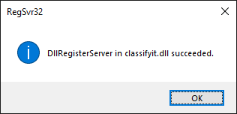

Deregister ClassifyIt.dll
To deregister, use the same architecture-specific regsvr32.exe as for registration, with /u and a quoted DLL path: regsvr32 /u "<PATH>\<FILENAME>".

Link ClassifyIt.json file
In the second step we need to tell ClassifyIt where to find the configuration file. Details for this are provided in Section Registry Keys
HKLM\SOFTWARE\CLASSIFY_IT\ (for 64-bit version of ClassifyIt)

Note: for the 32-bit version of ClassifyIt the key is stored at: HKLM\SOFTWARE\Wow6432Node\CLASSIFY_IT

Classification Properties
(X-Header Information)
ClassifyIt adds Properties and X-Header information to documents and emails.
The properties and X-Header information are Name: Value pairs. The name is specified in the configuration file under the "classifyit_control" section by "propertyKeyName" (see Section 5.04(iv)). The value is a JSON string with the following structure:
{"org": "ACME",
"class": "U",
"rel": []}

"org" identifies the originating organisation (configured via "originator" in "classifyit_control"). "class" and "rel" can be used by Data Leak Prevention (DLP) - their values are those of the "class" and "rel" fields in the "classifications" and "release_markings" sections, representing the actual classification and release assigned to the document.
We recommend using a standardised marking such as iCLASS, so that different deployments can recognise classification markings of each other.

Data Leak Protection (DLP)
Every document classified by ClassifyIt will, in addition to the human readable classifications, be tagged with machine readable property data. The Classification Properties section describes the data structure of the property data.
XML Guards or Application Guards can read the classification and release values to determine if the email or document can be transferred.

Prevent Disabling of ClassifyIt

Prevent ClassifyIt being disabled by a user
In general, Office add-ins can be disabled by a user. To prevent this for Office 2010, the following registry keys need to be created:
Outlook:
Key: HKEY_CURRENT_USER\Software\Microsoft\Office\14.0\Outlook\Security
Value: DontDisplayHKLMAddins (REG_DWORD) set value to 1

Ensure ClassifyIt is loaded at all times
Office evaluates the health and loading time of add-ins. ClassifyIt is sometimes flagged as taking too long to load. To prevent this set the following registry keys:
<ClassifyIt ID>: ClassifyIt.ClassifyIt_class

Go to registry key: HKEY_CURRENT_USER\SOFTWARE\Microsoft\Office\16.0\Outlook\Resiliency

Ensure the <ClassifyIt ID> is not listed in: HKEY_CURRENT_USER\SOFTWARE\Microsoft\Office\16.0\Outlook\Resiliency\CrashingAddinList

Add the <ClassifyIt ID> to: HKEY_CURRENT_USER\SOFTWARE\Microsoft\Office\16.0\Outlook\Resiliency\DoNotDisableAddinList as a DWORD with the value 1 (see below):

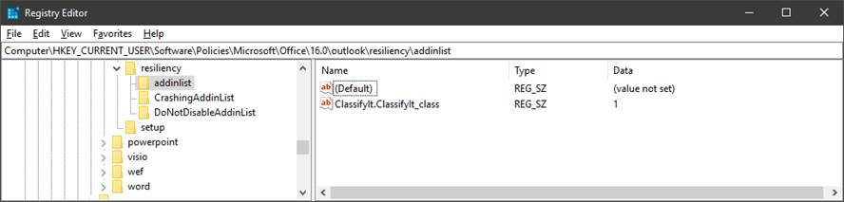

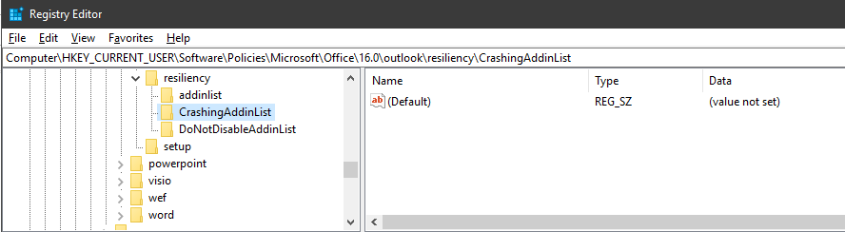

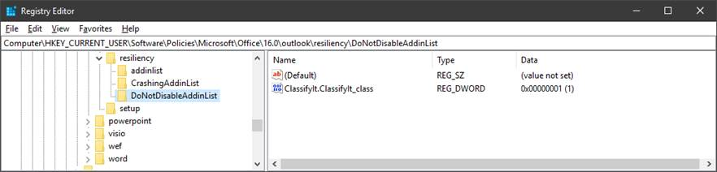

Information Manager
Input from the information manager (office) is important so that ClassifyIt is properly configured to reflect your needs for information security and classification.
The figures below provide an idea of what should be defined by the information manager. The classifications your company/administration is using to classify documents and emails, release markings, if those are used, and if so, wider release groups could be used.
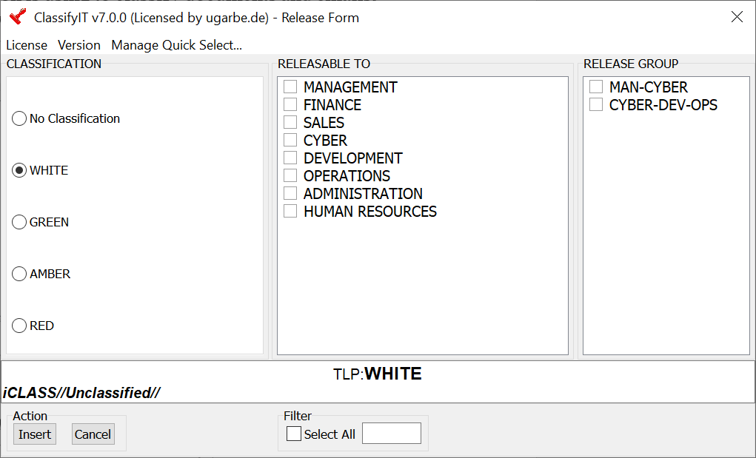
Figure 1 – Traffic Light Protocol Classification Marking – White, no release
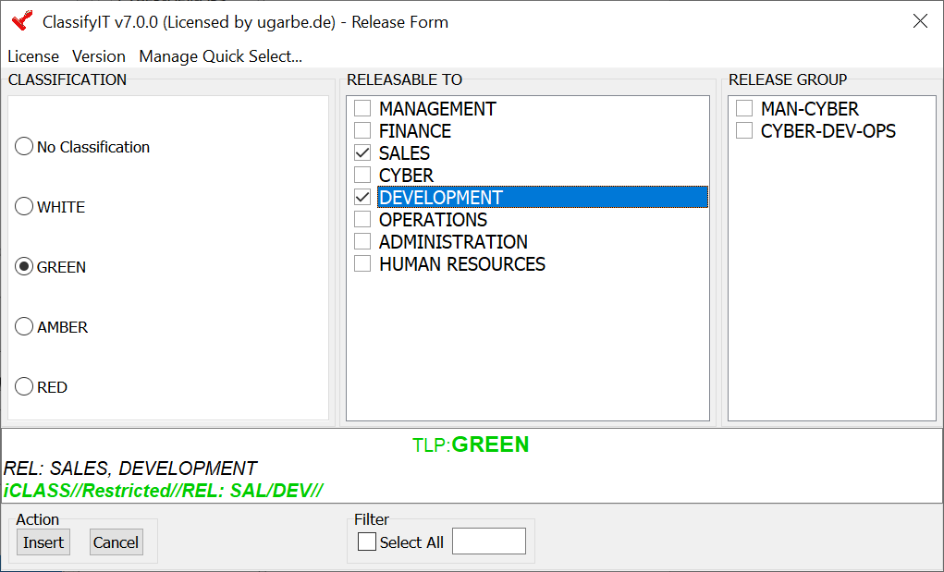
Figure 2 - TLP Marking - Green, with release
The figures above show the ClassifyIt Release Form with an example of the Traffic Light Protocol (TLP) markings (White, Green, Amber, Red). Other markings might be: Unclassified, Restricted, Confidential, Secret, Top Secret. ClassifyIt provides you with the option of any number of markings in any language and any Unicode character-set (UTF-8). ClassifyIt shows with the selection of classification and release what the actual marking looks like which could be inserted in the document the user is working on (below the selection areas).
The examples above also show a feature of ClassifyIt to provide a ‘translation’ of the markings. This is an important feature for information exchange between different companies or organisations, when not using the same classification marking. ugarbe.de suggests the use of an International Classification (iCLASS) which is well structured using standard classification markings in English language.
https://classifyit.eu/case-study/iclass

Classifications
List all classifications used by your organisation, in the order of lowest (e.g. public) level to the highest most protective level (e.g. secret). Optional, you could provide a screen tip the user would see when selecting a classification.
<please override the TLP example below with your policy>
- White
  - Screen Tip: Public Information, can be shared with everyone
  - Translation: Unclassified
- Green
  - Screen Tip: Information can be shared with Peers and Partner Organisations
  - Translation: Restricted
- Amber
  - Screen Tip: Information is critical and must be handled with care
  - Translation: Confidential
- Red
  - Screen Tip: Information is very critical and if wrongly distributed would have grave damage to our organisation
  - Translation: Secret

Release Markings
List all of the release markings your organisation uses, with a screen tip for the user. This is optional. If no release markings are necessary, please provide an empty list.
<please override the example below with your policy>

- Management
  - Screen Tip: Members of Management
  - Translation:
- Finance
  - Screen Tip: Office of Finance
  - Translation:
- …
- COMPANY_1
  - Screen Tip: Company 1
  - Translation:
- COMPANY_2
  - Screen Tip:
  - Translation:
- COMPANY_3
  - Screen Tip:
  - Translation:
- …

Release Groups
List the release groups which might be useful in your organisation. For a Release Group think about a named project your company has with other companies – for this named project you could define the project name as a Release Group, which would include the companies (e.g. COMPANY_1, COMPANY_3, COMPANY_8) – this makes it easier for the user to select the correct companies for sharing information. This feature is optional and only makes sense if you use Release Markings.
<please override the example below with your policy>
- PROJECT_1
  - Members: COMPANY_1, COMPANY_3, COMPANY_8
  - Screen Tip: Project 1 is about xxx
- PROJECT_2
  - Members: COMPANY_1, COMPANY_2, COMPANY_5, COMPANY_6
  - Screen Tip: Project 2 is about xxx
- …

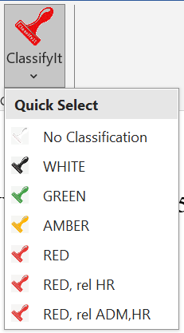
Quick Select
Provide your users a short list of frequently used classification markings. The marking has a display name and defines a classification and release marking – the release marking could be empty.
It is recommended to provide at least the classifications for this feature.
Users can modify and adjust this list later on while using ClassifyIt. However, it is recommended to provide a starting list of frequently used markings.
ClassifyIt restricts the number of Quick Select entries to 10.

<please override the example below with your policy>

  - Display: WHITE
  - Classification: White
  - Release:

  - Display: GREEN
  - Classification: Green
  - Release:
- …

  - Display: G rel M+F
  - Classification: Green
  - Release: Management, Finance
- …

Default Marking
Select which default marking should be applied to a new document or email. Normally this is either the lowest classification without a release, or the highest classification without a release. However, any defined classification and release could form the default marking.
<please override the example below with your policy>
- Classification: White
- Release: <>

Formatting
Last but not least the formatting of the classification marking needs to be described. ClassifyIt provides extensive options to display classification markings in the way as required by your policy.
To best approach the definition of the formatting, consider some examples. Consider the following:
- A classification in Outlook, Word, PowerPoint and Excel could have different preceding text. This preceding can have its own colour, font size, etc.
  - Example: some customers prefer for emails the expression “Classification:” in front of the classification.
  - Example: the classification of this document (WHITE) is preceded with the expression “TLP:” to indicate this is a TLP marking.
  - Preceding Outlook: < please fill >
  - Preceding Word: < please fill >
  - Preceding PowerPoint: < please fill >
  - Preceding Excel: < please fill >
  - Preceding Formatting:

iCLASS

iCLASS (International Classification) is the structured classification value used by ClassifyIt for machine-readable handling of classified information, and codes for human recognition. The visible text shown to users can be local, translated or policy-specific, but the iCLASS value should remain stable so that documents, emails, DLP systems and other receiving systems can interpret the marking consistently.

For administrators, the relevant configuration point is the property key, normally "iCLASS", defined by classifyit_control.propertyKeyName. ClassifyIt writes a JSON value containing the originator code ("org"), the classification code ("class") and the release codes ("rel") to document properties and email headers. These values are used by downstream controls such as DLP, mail gateways, XML/application guards and other ClassifyIt installations.

For information managers, iCLASS defines the controlled vocabulary behind the user-facing labels. Define the classification codes, classification levels, release codes, optional release groups, translated labels and the default marking before rollout. Classification levels should run from the least protective to the most protective marking, and release codes should identify the permitted recipients or communities. Avoid changing these codes after deployment unless migration and interoperability effects have been assessed.

Before operational deployment, verify that the visible marking, the document property and the email header all contain the expected iCLASS values for representative documents, emails and release-marking combinations.

ClassifyIt takes consistent and extensive use of iCLASS, as it is used for technical key-value pairs, representing the classification of a document or email, condensed versions of display for paragraph markings in word documents, and inclusion in TDF encrypted payload containers adding the iCLASS structure to the manifest.

16.0 for Office 2019 and Office 365

